 | October 2026 Evansville Care Center Activity Calendar
Sunday | Monday | Tuesday | Wednesday | Thursday | Friday | Saturday
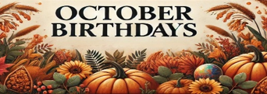  Stuart J.- 1st  Bruce O.- 3rd  Don G.- 4th  Betty C.- 5th | CALENDAR  IS SUBJECT TO CHANGE.  CALENDAR LOCATED ON CHANNEL 10.1 OR 10.2, PLEASE CHECK DAYROOM ACTIVITY BOARD FOR ANY UPDATES OR CHANGES. | 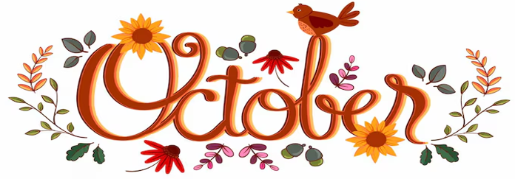 |  | 1 HAPPY BIRTHDAY STUART!!!  9:00- BEAUTY SHOP  10:00- WORDS IN WORDS  11:00- HEALTHY HEARTS CLUB  3:00- STUART’S BIRTHDAY PARTY!!  4:00- REACH CHURCH SERVICE | 2  9:30- CATHOLIC COMMUNION  10:00- DISCUSSION GROUP  11:00- HEALTHY HEARTS CLUB  2:00- BINGO  3:00- COFFEE TIME  4:00- CATHOLIC MASS | 3 HAPPY BIRTHDAY BRUCE!!!  1:00- POLKA SPOTLIGHT  2:00- MOVIE & SNACKS  3:00- BRUCE’S BIRTHDAY PARTY!!
4 HAPPY BIRTHDAY DON!!!  CHURCH SERVICES ON CHANNEL 43.1  1:00- POLKA SPOTLIGHT  3:00- DON’S BIRTHDAY PARTY!! | 5 HAPPY BIRTHDAY BETTY C.!!!  9:00- SPA DAY  11:00- HEALTHY HEARTS CLUB  2:00- MUSIC WITH NEIL & ORLO  3:00- BETTY’S BIRTHDAY PARTY!!  4:00- TV TRIVIA | 6  10:00- COMMUNION WITH PASTOR BRAD  11:00- HEALTHY HEARTS CLUB  2:00- BINGO  3:00- COFFEE TIME  4:00- FAITH CHURCH SERVICE | 7  10:00- BIBLE STUDY WITH BARB & FRIENDS  11:00- HEALTHY HEARTS CLUB  12:00- GERMAN DINNER  2:00-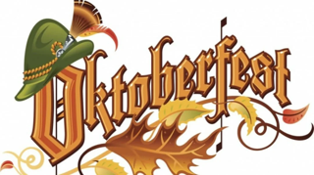 | 8  9:00- BEAUTY SHOP  10:00- WORDS IN WORDS  11:00- HEALTHY HEARTS CLUB 2:00- THE HOLMQUISTS  3:00- COFFEE TIME  4:00- REACH CHURCH SERVICE | 9  9:30- CATHOLIC COMMUNION  10:00- DISCUSSION GROUP  11:00- HEALTHY HEARTS CLUB  2:00- BINGO  3:00- COFFEE TIME  4:00- CATHOLIC MASS | 10  10:00- LEFT, RIGHT, CENTER  1:00- SHORT STORIES  2:15- CHURCH WITH DUANE  3:00- COFFEE TIME  3:30- MOVIE & POPCORN
11  CHURCH SERVICES ON CHANNEL 43.1  1:00- POLKA SPOTLIGHT  3:00- COFFEE TIME | 12  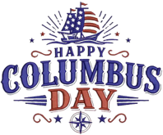 | 13  10:00- HYMNS WITH PASTOR NATE  11:00- HEALTHY HEARTS CLUB  1:00- BOOKMOBILE  2:00- BINGO  3:00- COFFEE TIME  4:00- FAITH CHURCH SERVICE | 14  10:15- NAME THAT TUNE WITH MARYANN  11:00- HEALTHY HEARTS CLUB  1:00- CRAFTS  3:00- COFFEE TIME  3:30- PUZZLE PALS | 15  7:45- FARMERS BREAKFAST  9:00- BEAUTY SHOP  10:00- WORDS IN WORDS  11:00- HEALTHY HEARTS CLUB  2:00- FARMING ACTIVITY  3:00- COFFEE TIME  4:00- REACH CHURCH SERVICE | 16  9:30- CATHOLIC COMMUNION  10:00- DISCUSSION GROUP  11:00- HEALTHY HEARTS CLUB  2:00- BINGO  3:00- COFFEE TIME  4:00- CATHOLIC MASS | 17  1:00- POLKA SPOTLIGHT  2:00- MOVIE & SNACKS  3:00- COFFEE TIME
18  CHURCH SERVICES ON CHANNEL 43.1  1:00- POLKA SPOTLIGHT  3:00- COFFEE TIME | 19  9:00- SPA DAY  11:00- HEALTHY HEARTS CLUB 2:00- RESIDENT COUNCIL MEETING  3:00- COFFEE TIME  3:30- MUSIC PLAYLIST | 20  10:00- COMMUNION WITH PASTOR BRAD  11:00- HEALTHY HEARTS CLUB  2:00- BINGO  3:00- COFFEE TIME  4:00- FAITH CHURCH SERVICE | 21  10:00- HEALTHY HEARTS CLUB 11:00- FOOD COUNCIL MEETING  1:00- CRAFTS  3:00- COFFEE TIME  3:30- TRIVIA | 22  9:00- BEAUTY SHOP  10:30- MASS WITH FATHER THEIS  11:00- HEALTHY HEARTS CLUB  3:00- COFFEE TIME  4:00- REACH CHURCH SERVICE | 23  NO CATHOLIC COMMUNION  10:00- DISCUSSION GROUP  11:00- HEALTHY HEARTS CLUB  2:00- BINGO  3:00- COFFEE TIME  4:00- CATHOLIC MASS | 24  10:00- PENNY ANTE  1:00- SHORT STORIES  2:15- CHURCH WITH DUANE  3:00- COFFEE TIME  3:30- MOVIE & POPCORN
25  CHURCH SERVICES ON CHANNEL 43.1  1:00- POLKA SPOTLIGHT  3:00- COFFEE TIME | 26  9:00- SPA DAY  11:00- HEALTHY HEARTS CLUB  2:00- GRIEF SUPPORT GROUP  3:00- COFFEE TIME  3:30- TV TRIVIA | 27  10:00- HYMNS WITH PASTOR NATE  11:00- HEALTHY HEARTS CLUB 1:00- BOOKMOBILE  2:00- BINGO  3:00- COFFEE TIME  4:00- FAITH CHURCH SERVICE | 28  10:00- PUMPKIN BALLOON BALL  11:00- HEALTHY HEARTS CLUB  1:00- PUMPKIN CARVING  3:00- COFFEE TIME  3:30- PUZZLE PALS | 29  9:00- BEAUTY SHOP  10:00- WORDS IN WORDS  11:00- HEALTHY HEARTS CLUB  2:00- HALLOWEEN GAMES  3:00- COFFEE TIME  4:00- REACH CHURCH SERVICE | 30 WEAR YOUR COSTUMES!!  9:30- CATHOLIC COMMUNION  10:00- DISCUSSION GROUP  11:00- HEALTHY HEARTS CLUB  2:00- BINGO  3:00- COFFEE TIME  3:30- SCHJEI COUNTRY MUSIC  4:00- CATHOLIC MASS | 31 WEAR YOUR COSTUMES!!  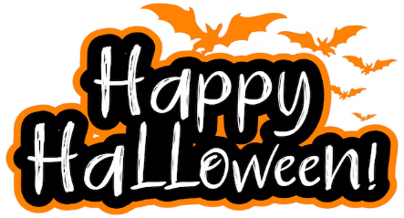4:00- 7:00-TRICK OR TREATING

