 | November 2025 Evansville Care Center Activity Calendar
Sunday | Monday | Tuesday | Wednesday | Thursday | Friday |  | Saturday
  NO BIRTHDAYS |  |  |  |  | 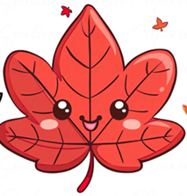 |  | 1  1:00- POLKA SPOTLIGHT  2:00- MOVIE & SNACKS  3:00- COFFEE TIME
2  DAYLIGHT SAVINGS TIME ENDS,  SET YOUR CLOCKS BACK  CHURCH SERVICES ON CHANNEL 43.1  1:00- POLKA SPOTLIGHT  3:00- COFFEE TIME | 3  9:00- SPA DAY  11:00- HEALTHY HEARTS CLUB  11:30- DINNER TRIVIA  2:00- MUSIC WITH STAN KLUG  3:00- COFFEE TIME   | 4  10:00- COMMUNION WITH PASTOR BRAD  11:00- HEALTHY HEARTS CLUB  2:00- BINGO  3:00- COFFEE TIME  4:00- GRACE CHURCH SERVICE | 5  10:00- DEVOTIONS WITH BARB & FRIENDS  11:00- HEALTHY HEARTS CLUB  12:00- LIVER & ONION DINNER  1:00- TRIVIA  3:00- COFFEE TIME  3:30- CHARM BRACELET CRAFT | 6  9:00- BEAUTY SHOP  10:30- MASS WITH FATHER THEIS  11:00- HEALTHY HEARTS CLUB  2:00- DEER HUNTING  3:00- COFFEE TIME  4:00- REACH CHURCH SERVICE | 7  NO CATHOLIC COMMUNION  10:00- DISCUSSION GROUP  11:00- HEALTHY HEARTS CLUB  2:00- BINGO  3:00- COFFEE TIME  4:00- CATHOLIC MASS |  | 8 DEER HUNTING OPENER  10:00- LEFT, RIGHT, CENTER  1:00- SHORT STORIES  3:00- COFFEE TIME  3:30- MOVIE & POPCORN
9  CHURCH SERVICES ON CHANNEL 43.1  1:00- POLKA SPOTLIGHT  3:00- COFFEE TIME | 10  9:00- SPA DAY  11:00- HEALTHY HEARTS CLUB  11:30- DINNER TRIVIA  2:00- RESIDENT COUNCIL MEETING  3:00- COFFEE TIME  4:00- GRACE CHURCH SERVICE | 11  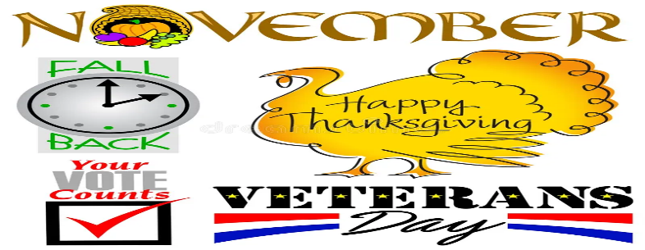10:00- HYMNS WITH PASTOR NATE  11:00- HEALTHY HEARTS CLUB  2:00- BINGO  3:00- COFFEE TIME  3:30- VETERANS DAY GATHERING | 12  10:15- NAME THAT TUNE WITH MARYANN  11:00- HEALTHY HEARTS CLUB  1:00- TRIVIA  3:00-COFFEE TIME SERVING MAPLE PECAN LATTES   | 13  7:45- WAFFLES WITH BRANDON  9:00- BEAUTY SHOP  10:00- WORDS IN WORDS  11:00- HEALTHY HEARTS CLUB  2:00- THE HOLMQUISTS  3:00- COFFEE TIME  4:00- REACH CHURCH SERVICE | 14  9:30- CATHOLIC COMMUNION  10:00- DISCUSSION GROUP  11:00- HEALTHY HEARTS CLUB  2:00- BINGO  3:00- COFFEE TIME  4:00- CATHOLIC MASS |  | 15  1:00- POLKA SPOTLIGHT  2:00- MOVIE & SNACKS  3:00- COFFEE TIME
16  CHURCH SERVICES ON CHANNEL 43.1  1:00- POLKA SPOTLIGHT  3:00- COFFEE TIME | 17  9:00- SPA DAY  11:00- HEALTHY HEARTS CLUB  11:30- DINNER TRIVIA  3:00- COFFEE TIME  3:30- WHEEL OF FORTUNE | 18  10:00- COMMUNION WITH PASTOR BRAD  11:00- HEALTHY HEARTS CLUB  2:00- BINGO  3:00- COFFEE TIME  4:00- GRACE CHURCH SERVICE | 19  11:00- FOOD COUNCIL MEETING  1:00- HEALTHY HEARTS CLUB  2:00- MUSIC WITH COBALT CANYON  3:00- COFFEE TIME  3:30- BALLOON VOLLEYBALL | 20  9:00- BEAUTY SHOP  10:00- WORDS IN WORDS  11:00- HEALTHY HEARTS CLUB  3:00- COFFEE TIME  2:15- AGE TO AGE  4:00- REACH CHURCH SERVICE | 21  9:30- CATHOLIC COMMUNION  10:00- DISCUSSION GROUP  11:00- HEALTHY HEARTS CLUB  2:00- BINGO  3:00- COFFEE TIME  4:00- CATHOLIC MASS |  | 22  10:00- PENNY ANTE  1:00- SHORT STORIES  3:00- COFFEE TIME  3:30- MOVIE & POPCORN
23  CHURCH SERVICES ON CHANNEL 43.1  1:00- POLKA SPOTLIGHT  3:00- COFFEE TIME | 24  9:00- SPA DAY  11:00- HEALTHY HEARTS CLUB  11:30- DINNER TRIVIA  2:00- GRIEF SUPPORT GROUP  3:00- COFFEE TIME  3:30- YATZEE | 25  10:00- HYMNS WITH PASTOR NATE  11:00- HEALTHY HEARTS CLUB  1:00- BOOKMOBILE  2:00- BINGO  3:00- COFFEE TIME  4:00- GRACE CHURCH SERVICE | 26  9:00- BEAUTY SHOP  10:00- COLORING CLUB  11:00- HEALTHY HEARTS CLUB  1:00- TRIVIA  3:00- COFFEE TIME  3:30- THANKSGIVING CROSSWORD | 27    10:00- WORDS IN WORDS  11:00- HEALTHY HEARTS CLUB  12:00- THANKSGIVING DINNER  3:00- COFFEE TIME  4:00- REACH CHURCH SERVICE | 28  9:30- CATHOLIC COMMUNION  10:00- DISCUSSION GROUP  11:00- HEALTHY HEARTS CLUB  2:00- BINGO  3:00- COFFEE TIME  4:00- CATHOLIC MASS |  | 29  1:00- POLKA SPOTLIGHT  2:00- MOVIE & SNACKS  3:00- COFFEE TIME
30  CHURCH SERVICES ON CHANNEL 43.1  1:00- POLKA SPOTLIGHT  3:00- COFFEE TIME |  |  |  |  |  | CALENDAR  IS SUBJECT TO CHANGE.  CALENDAR LOCATED ON CHANNEL 10.1, PLEASE CHECK DAYROOM ACTIVITY BOARD FOR ANY UPDATES OR CHANGES.

