October 2025 Evansville Care Center Activity Calendar
Sunday | Monday | Tuesday | Wednesday | Thursday | Friday | Saturday
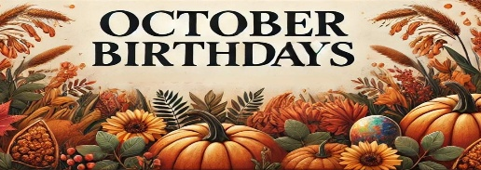  Stuart J.- 1st  Bruce O.- 3rd  Betty C.- 5th | 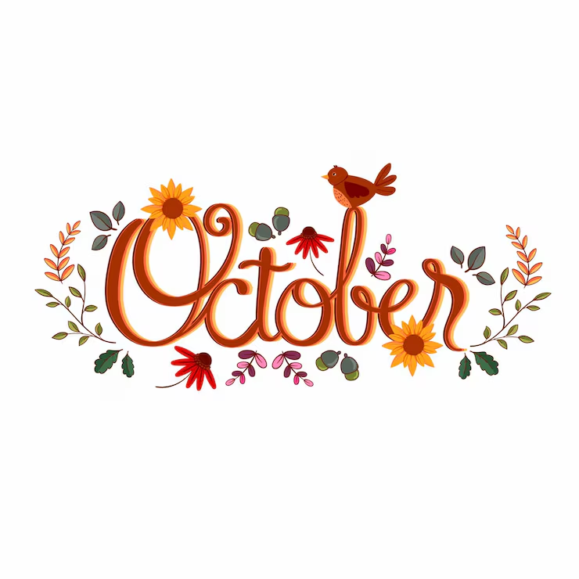 |  | 1 HAPPY BIRTHDAY STUART J!!!  10:00- DEVOTIONS WITH BARB & FRIENDS  11:00- HEALTHY HEARTS CLUB  1:00- TRIVIA  3:00- STUART’S BIRTHDAY PARTY!! | 2  9:00- BEAUTY SHOP  10:30- MASS WITH FATHER THEIS  11:00- HEALTHY HEARTS CLUB  2:00- CRAFT  3:00- COFFEE TIME  4:00- REACH CHURCH SERVICE | 3 HAPPY BIRTHDAY BRUCE O!!!  NO CATHOLIC COMMUNION  10:00- DISCUSSION GROUP  11:00- HEALTHY HEARTS CLUB  2:00- BINGO  3:00- BRUCE’S BIRTHDAY PARTY!!  4:00- CATHOLIC MASS | 4  1:00- POLKA SPOTLIGHT  2:00- MOVIE & SNACKS  3:00- COFFEE TIME  
5 HAPPY BIRTHDAY BETTY C!!!  CHURCH SERVICES ON CHANNEL 43.1  1:00- POLKA SPOTLIGHT  3:00- COFFEE TIME   | 6  9:00- SPA DAY  11:00- HEALTHY HEARTS CLUB  11:30- DINNER TRIVIA  2:00- MUSIC WITH NEIL & ORLO  3:00- BETTY’S BIRTHDAY PARTY!!  4:00- GRACE CHURCH SERVICE | 7  10:00- COMMUNION WITH PASTOR BRAD  11:00- HEALTHY HEARTS CLUB  2:00- BINGO  3:00- COFFEE TIME | 8  10:15- NAME THAT TUNE WITH MARYANN  11:00- HEALTHY HEARTS CLUB  12:00- GERMAN DINNER  2:00- OKTOBERFEST PARTY  3:00-COFFEE TIME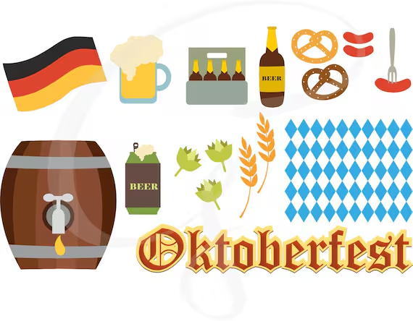 | 9  7:45- WAFFLES WITH BRANDON  9:00- BEAUTY SHOP  10:00- WORDS IN WORDS  11:00- HEALTHY HEARTS CLUB  2:00- THE HOLMQUISTS  3:00- COFFEE TIME  4:00- REACH CHURCH SERVICE | 10  9:30- CATHOLIC COMMUNION  10:00- DISCUSSION GROUP  11:00- HEALTHY HEARTS CLUB  2:00- BINGO  3:00- COFFEE TIME  4:00- CATHOLIC MASS | 11  10:00- LEFT, RIGHT, CENTER  1:00- SHORT STORIES  3:00- COFFEE TIME  3:30- MOVIE & POPCORN
12  CHURCH SERVICES ON CHANNEL 43.1  1:00- POLKA SPOTLIGHT  3:00- COFFEE TIME | 13 COLUMBUS DAY  10:00-HAND & SHOULDER MASSAGES  11:00- HEALTHY HEARTS CLUB  11:30- DINNER TRIVIA  2:00- COLORING/ACTIVITY PAGE  3:00- COFFEE TIME | 14  10:00- HYMNS WITH PASTOR NATE  11:00- HEALTHY HEARTS CLUB  1:00- BOOKMOBILE  2:00- BINGO  3:00- COFFEE TIME  4:00- GRACE CHURCH SERVICE | 15 WEAR YOUR PLAID SHIRTS  7:45- FARMERS BREAKFAST  11:00- FOOD COUNCIL MEETING  1:00- HEALTHY HEARTS CLUB  2:00- FARMING ACTIVITY  3:00- COFFEE & DONUTS  3:30- FARM ANIMAL TRIVIA | 16  9:00- BEAUTY SHOP  10:00- WORDS IN WORDS  11:00- HEALTHY HEARTS CLUB  2:00- RESIDENT COUNCIL MEETING  3:00- COFFEE TIME  4:00- REACH CHURCH SERVICE | 17  9:30- CATHOLIC COMMUNION  10:00- DISCUSSION GROUP  11:00- HEALTHY HEARTS CLUB  2:00- BINGO  3:00- COFFEE TIME  4:00- CATHOLIC MASS | 18  1:00- POLKA SPOTLIGHT  2:00- MOVIE & SNACKS  3:00- COFFEE TIME
19  CHURCH SERVICES ON CHANNEL 43.1  1:00- POLKA SPOTLIGHT  3:00- COFFEE TIME | 20  9:00- SPA DAY  11:00- HEALTHY HEARTS CLUB  11:30- DINNER TRIVIA  2:00- HALLOWEEN NECKLACE MAKING  3:00- COFFEE TIME | 21  10:00- COMMUNION WITH PASTOR BRAD  11:00- HEALTHY HEARTS CLUB  2:00- BINGO  3:00- COFFEE TIME  4:00- GRACE CHURCH SERVICE | 22  11:00- HEALTHY HEARTS CLUB  1:00- TRIVIA  2:15- AGE TO AGE  3:00- COFFEE TIME SERVING PUMPKIN SPICE LATTES  3:30- COLORING | 23  9:00- BEAUTY SHOP  10:00- WORDS IN WORDS  11:00- HEALTHY HEARTS CLUB  2:00-TAILGATE PARTY  3:00- COFFEE TIME  4:00- REACH CHURCH SERVICE  7:15-VIKINGS VS. CHARGERS | 24  9:30- CATHOLIC COMMUNION  10:00- DISCUSSION GROUP  11:00- HEALTHY HEARTS CLUB  2:00- BINGO  3:00- COFFEE TIME  4:00- CATHOLIC MASS | 25  10:00- PENNY ANTE  1:00- SHORT STORIES  3:00- COFFEE TIME  3:30- MOVIE & POPCORN
26  CHURCH SERVICES ON CHANNEL 43.1  1:00- POLKA SPOTLIGHT  3:00- COFFEE TIME | 27  9:00- SPA DAY  11:00- HEALTHY HEARTS CLUB  11:30- DINNER TRIVIA  2:00- GRIEF SUPPORT GROUP  3:00- COFFEE TIME  3:30- PUMPKIN PUTT-PUTT | 28  10:00- HYMNS WITH PASTOR NATE  11:00- HEALTHY HEARTS CLUB  1:00- BOOKMOBILE  2:00- BINGO  3:00- COFFEE TIME  4:00- GRACE CHURCH SERVICE | 29  10:00- HALLOWEEN CROSSWORD  11:00- HEALTHY HEARTS CLUB  1:00- TRIVIA  2:00- MARSHMALLOW GHOST STACK  3:00- COFFEE TIME  3:30- JACK-O-LANTERN CARVING | 30  9:00- BEAUTY SHOP  10:00- WORDS IN WORDS  11:00- PUMPKIN BALLOON BALL  2:00- SPIDER KERPLUNK  3:00- COFFEE TIME  4:00- REACH CHURCH SERVICE | 31 HAPPY HALLOWEEN  WEAR YOUR COSTUMES!!  9:30- CATHOLIC COMMUNION  10:00- DISCUSSION GROUP  11:00- HEALTHY HEARTS CLUB  1:30- BINGO  2:30- COFFEE TIME  3:00- MUSIC WITH SCHJEI COUNTRY  4:00- CATHOLIC MASS  TRICK OR TREATERS | CALENDAR  IS SUBJECT TO CHANGE.  CALENDAR LOCATED ON CHANNEL 10.1, PLEASE CHECK DAYROOM ACTIVITY BOARD FOR ANY UPDATES OR CHANGES.

